INFORMED CONSENT FORM
Study Title: “Ez-Print: A Web Based Service From STI Where You Can Submit Your Files And Choose Your Print Shop”

Researchers: Group 5 – MAWD 301

Good day! We are students from MAWD 401 conducting a research study titled “Ez-Print: A Web Based Service From STI Where You Can Submit Your Files And Choose Your Print Shop” The purpose of this study is to gather information about students’ experiences, opinions, and suggestions to help improve engagement, communication, and organization through a web-based club management system.

Your participation in this study will involve answering a set of interview questions, which will take approximately 10–15 minutes. Your participation is entirely voluntary, and you have the right to refuse to answer any question or withdraw from the interview at any time without any consequences.

All information you provide will be treated with strict confidentiality and will be used for academic purposes only. Your identity will not be revealed in any part of this research.

By signing below, you confirm that you have read and understood the information provided above and that you voluntarily agree to participate in this study.

Participant’s Name: _________________________
Signature: _________________________
Date: _________________________

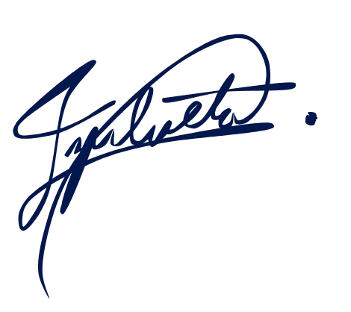
Researcher’s Name: Eli John Zulueta____
Signature: _________________________
Date: _________________________

